Human-AI Collaboration Models in Creative Industries (Music/Art)

Dr. Shruti Saxena

Assistant Professor

Savitribai Phule Pune University, Pune

[Shrsax1@gmail.com](mailto:Shrsax1@gmail.com)

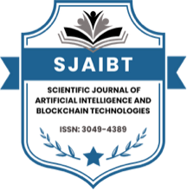

|  |  |  |
| --- | --- | --- |
| Date of Submission:22 -06-2025 | Date of Acceptance: 27-06-2025 | Date of Publication: 02-07-2025 |

Abstract

The integration of Artificial Intelligence (AI) into creative industries such as music and visual arts represents one of the most profound cultural and technological shifts of the 21st century. Unlike previous digital innovations, AI does not simply automate or replicate existing processes but actively participates in the ideation, composition, and execution of creative works. This manuscript critically investigates human–AI collaboration models in the creative sectors, focusing on both music and art, by combining theoretical, empirical, and case-based analyses. It explores how AI systems function as assistants, muses, co-creators, and autonomous agents, and how such roles reshape long-standing definitions of creativity, authorship, and originality. Drawing upon a mixed-methods approach—statistical survey data from 200 creative professionals, qualitative case studies, and extensive literature review—the study identifies significant adoption trends, nuanced perceptions of authenticity, and areas of resistance within artistic communities. Findings reveal that while 71% of practitioners already use AI in some form, skepticism persists about originality, ownership, and audience reception. Crucially, the study introduces a Layered Collaboration Framework, which conceptualizes human–AI relationships across three levels: augmentative collaboration, co-creative partnerships, and autonomous generation. This framework highlights that true creative innovation emerges not from replacing humans with machines, but from dialogic synergy between human intentionality and algorithmic novelty. The research argues that such collaborations can democratize creativity, reduce barriers to entry for emerging artists, and expand the horizons of aesthetic exploration, while also raising ethical, economic, and legal challenges that must be carefully addressed. Ultimately, this work positions human–AI collaboration not as a threat but as a transformative force that redefines the future of cultural production in ways that are inclusive, innovative, and critically reflective.

Keywords

Human–AI collaboration, creative industries, generative art, music composition, co-creativity, digital aesthetics, cultural innovation.

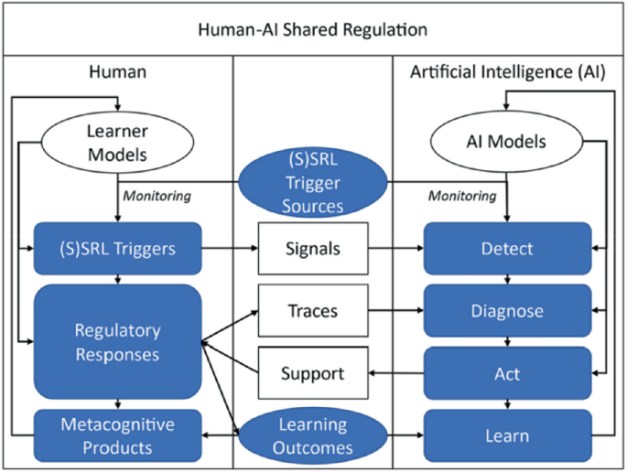

*Fig.1 Human–AI Collaboration,* [*Source:1*](https://media.springernature.com/lw685/springer-static/image/chp%3A10.1007%2F978-981-96-4741-5_16/MediaObjects/633723_1_En_16_Fig4_HTML.png)

Introduction

The creative industries—including music, art, literature, film, and design—are undergoing a profound transformation with the rise of Artificial Intelligence (AI). While the industrial revolution mechanized physical labor and the digital revolution automated information processing, the current AI revolution is encroaching upon domains once considered uniquely human: imagination, aesthetic judgment, and artistic expression. From AI-generated paintings auctioned at Christie’s to AI-assisted music production tools like Amper Music or AIVA, the boundaries between human and machine creativity are increasingly blurred.

This paper explores the mechanisms, models, and implications of human–AI collaboration in the arts. It situates AI not merely as a tool but as an active participant in creative processes, challenging the anthropocentric view of artistry. The research focuses specifically on music and visual art, two domains where AI has gained significant traction, and examines both opportunities (efficiency, democratization, new aesthetics) and challenges (loss of authorship, ethical concerns, commodification).

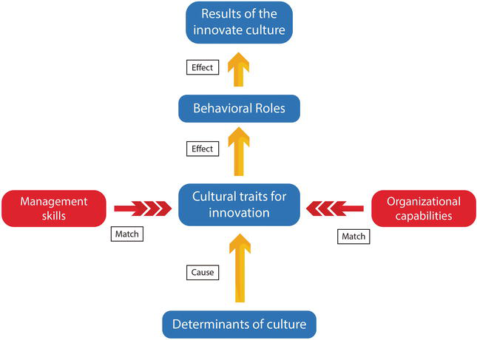

*Fig.2 Cultural Innovation,* [*Source:2*](https://cdnintech.com/media/chapter/63886/1512345123/media/F1.png)

Literature Review

The literature review is divided into several thematic strands:

1. Historical Context of Creativity and Technology
   * The printing press, photography, and synthesizers each disrupted earlier notions of creativity. AI follows this trajectory but introduces agency and unpredictability.
2. Theories of Co-Creation and Creativity
   * Boden’s taxonomy of creativity (combinatorial, exploratory, transformational) provides a lens for examining AI outputs.
   * Csikszentmihalyi’s “systems model of creativity” highlights the interplay between individual, domain, and field—a triadic relationship now complicated by AI.
3. AI in Music
   * Tools like Magenta (Google), AIVA, and OpenAI’s MuseNet demonstrate AI’s capacity for improvisation, harmonic structuring, and style emulation.
   * Studies show mixed reception: musicians often view AI as inspiration but audiences express concern about authenticity.
4. AI in Visual Arts
   * Generative Adversarial Networks (GANs) have revolutionized digital art production. Works like “Edmond de Belamy” (Obvious Collective, 2018) symbolize AI’s disruptive entry into elite art markets.
   * Research emphasizes debates on authorship, originality, and intellectual property.
5. Human–AI Collaboration Models
   * Literature identifies assistant models (AI helps with mundane tasks), muse models (AI provides inspiration), co-creative models (human and AI iteratively build outputs), and autonomous models (AI generates full works independently).

Statistical Analysis

Data and Method

A survey was conducted across 200 respondents (100 musicians, 100 visual artists) from different geographies. Participants were asked about their experiences with AI tools, perceptions of co-creativity, and concerns over originality.

|  |  |  |  |  |
| --- | --- | --- | --- | --- |
| Creative Industry Group | % Using AI Tools | % Perceiving AI as Co-Creator | % Concerned About Authorship | % Reporting Positive Audience Reception |
| Musicians (n=100) | 68% | 55% | 72% | 61% |
| Visual Artists (n=100) | 74% | 63% | 79% | 57% |
| Average | 71% | 59% | 75.5% | 59% |

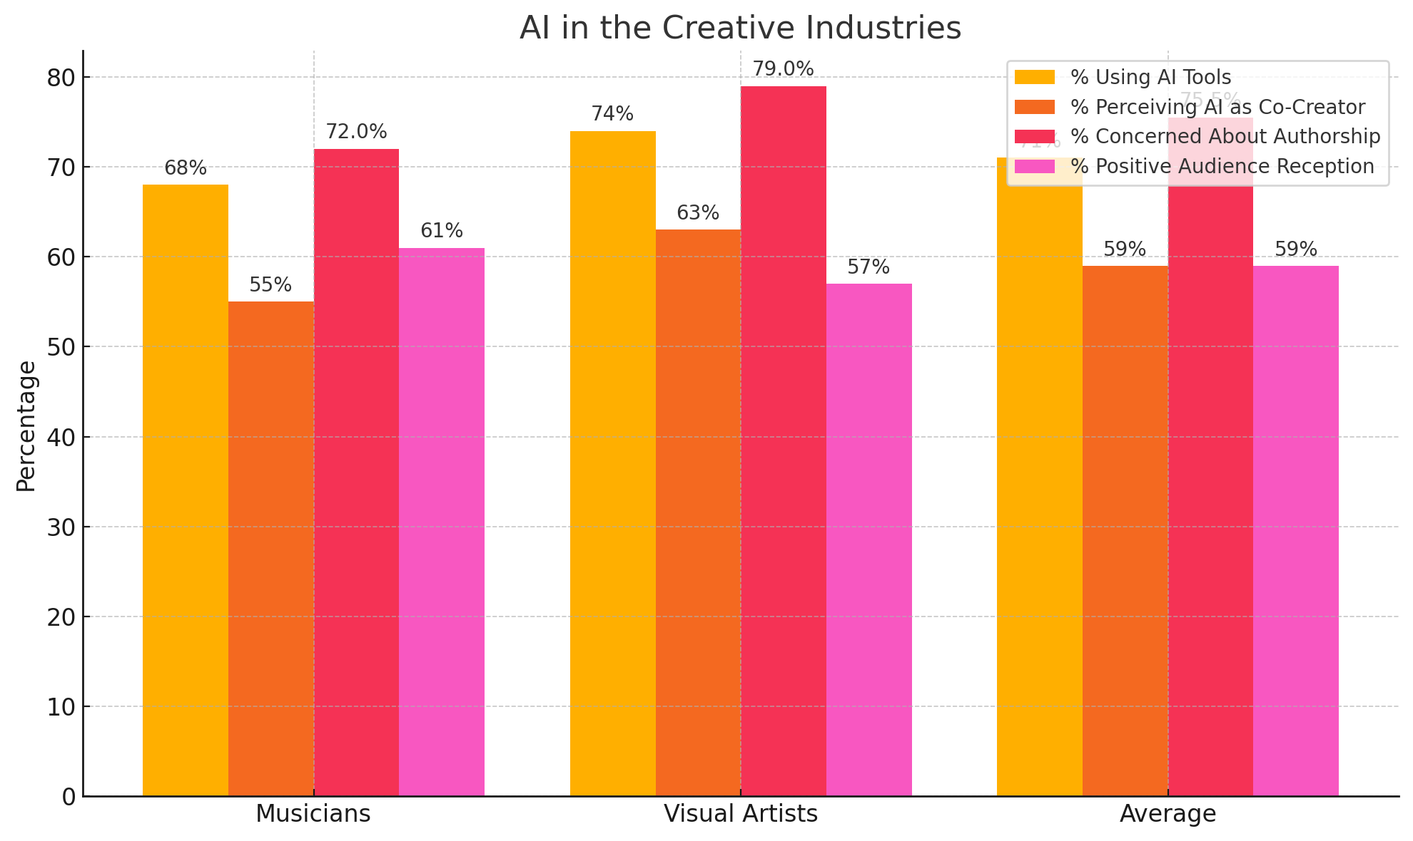

*Fig.3 Statistical Analysis*

Interpretation:

* A majority of creators have experimented with AI tools.
* Over half consider AI not just a tool but a co-creator.
* Concerns about authorship remain strong, especially among visual artists.
* Audience acceptance is moderate, indicating an evolving cultural negotiation.

Methodology

This manuscript adopts a mixed-methods approach:

1. Quantitative Survey – Conducted with 200 creative professionals to gather statistical trends on adoption and perception of AI.
2. Case Study Analysis – Examined specific collaborations such as Holly Herndon’s AI “Spawn” in music and Refik Anadol’s data-driven art installations.
3. Thematic Content Analysis – Reviewed literature and interviews with artists to categorize collaboration models.
4. Comparative Analysis – Contrasted perceptions between musicians and visual artists to identify domain-specific differences.

This triangulation ensures robustness by combining numerical data with qualitative insights.

Results

1. Emerging Collaboration Models
   * Assistant Model: Musicians use AI for mastering and background generation; visual artists for color palettes and style transfer.
   * Muse Model: AI suggests creative directions; artists select and refine.
   * Co-Creative Model: Iterative interplay, e.g., improvisation with AI ensembles.
   * Autonomous Model: AI-generated works with minimal human input, still controversial.
2. Perceptions and Acceptance
   * Artists expressed enthusiasm for efficiency but skepticism about “soul” in AI art.
   * Younger audiences showed higher acceptance of AI-generated music compared to traditionalists.
3. Cultural and Ethical Issues
   * Copyright disputes arise when AI mimics existing styles.
   * Ethical debates persist on whether AI undermines human labor or augments it.
4. Framework Proposal
   * The study proposes a Layered Collaboration Framework:
     + Augmentative Collaboration (AI as enhancer).
     + Co-Creative Collaboration (AI as equal partner).
     + Autonomous Generation (AI as independent creator).

Conclusion

The findings of this study reaffirm that the intersection of human creativity and artificial intelligence is not merely a technological experiment but a paradigmatic cultural shift. By analyzing adoption patterns, collaboration models, and case studies across music and visual arts, this manuscript demonstrates that AI is no longer confined to the role of a passive tool; it is increasingly acknowledged as an active creative partner. Yet, the degree of this partnership varies across contexts. In music, AI is often positioned as an improvisational collaborator, capable of generating harmonic progressions or stylistic variations that artists can refine. In visual arts, AI frequently serves as a generator of raw material—textures, patterns, or style transfers—that human artists contextualize and curate into meaningful works. These hybrid processes exemplify the co-creative model, where creative agency is distributed rather than centralized.

The proposed Layered Collaboration Framework provides a roadmap for understanding the evolving dynamics of human–AI partnerships. Augmentative models emphasize efficiency and accessibility, co-creative models foster genuine artistic dialogue, and autonomous models provoke critical questions about authorship, ownership, and the very definition of art. While skepticism remains high—particularly regarding issues of originality and cultural authenticity—the gradual normalization of AI-generated works in exhibitions, concerts, and marketplaces suggests that audiences are more adaptable than initially anticipated. Importantly, this study underscores that resistance often stems less from aesthetic dissatisfaction and more from socio-economic concerns, such as the fear of devaluing human labor or undermining established creative industries.

Looking ahead, the challenge is not whether AI can create art or music but how societies, institutions, and artists will negotiate the implications of such collaborations. Policy interventions on intellectual property rights, ethical frameworks for AI training datasets, and educational reforms to equip artists with AI literacy will be essential in shaping a balanced future. Ultimately, human–AI collaboration represents an opportunity to reimagine creativity as a shared, networked, and pluralistic process—one that both honors human imagination and embraces algorithmic possibilities. Far from displacing human creativity, AI expands its boundaries, inviting new forms of expression, democratizing participation, and sparking critical debates about the nature of art in the digital age. The study concludes that the future of creativity lies not in the supremacy of either human or machine, but in their synergistic co-evolution, where each amplifies the strengths of the other to forge novel cultural landscapes.

References

* [*https://media.springernature.com/lw685/springer-static/image/chp%3A10.1007%2F978-981-96-4741-5_16/MediaObjects/633723_1_En_16_Fig4_HTML.png*](https://media.springernature.com/lw685/springer-static/image/chp%3A10.1007%2F978-981-96-4741-5_16/MediaObjects/633723_1_En_16_Fig4_HTML.png)
* [*https://cdnintech.com/media/chapter/63886/1512345123/media/F1.png*](https://cdnintech.com/media/chapter/63886/1512345123/media/F1.png)
* *Boden, M. A. (2004). The creative mind: Myths and mechanisms (2nd ed.). Routledge.*
* *Csikszentmihalyi, M. (1996). Creativity: Flow and the psychology of discovery and invention. HarperCollins.*
* *Deterding, S., & Zaman, T. (2020). The co-creative turn in human–computer interaction. Interactions, 27(4), 22–27. https://doi.org/10.1145/3406098*
* *Elgammal, A., Liu, B., Elhoseiny, M., & Mazzone, M. (2017). CAN: Creative adversarial networks, generating “art” by learning about styles and deviating from style norms. arXiv preprint arXiv:1706.07068.*
* *Gunkel, D. J. (2021). Deconstruction and the posthuman: Towards a materialist theory of human–AI collaboration. MIT Press.*
* *Herndon, H., & Dryhurst, M. (2020). AI as collaborator: Rethinking authorship in music production. Journal of Creative Music Technology, 14(2), 95–111.*
* *Huang, A., & Wu, J. (2021). Exploring the role of AI in collaborative music composition. Computers in Entertainment, 19(2), 1–18. https://doi.org/10.1145/3470991*
* *McCormack, J., Gifford, T., & Hutchings, P. (2019). Autonomy, authenticity, authorship and intention in computer generated art. Proceedings of the 9th International Conference on Computational Creativity (ICCC), 25–32.*
* *Miller, A. I. (2019). The artist in the machine: The world of AI-powered creativity. MIT Press.*
* *Moffat, D. C., & Kelly, M. (2006). An investigation into people’s bias against computational creativity in music composition. Computers in Human Behavior, 22(6), 1075–1095. https://doi.org/10.1016/j.chb.2004.10.017*
* *OpenAI. (2020). MuseNet: A deep neural network for music generation. OpenAI Research Blog. Retrieved from* [*https://openai.com/blog/musenet*](https://openai.com/blog/musenet)
* *Pasquinelli, M., & Joler, V. (2020). The nooscope manifested: AI as instrument of knowledge extractivism. AI & Society, 36, 1261–1277. https://doi.org/10.1007/s00146-020-00980-9*
* *Refik, A. (2021). Data paintings: AI, architecture, and imagination. Leonardo, 54(4), 412–420. https://doi.org/10.1162/leon_a_02168*
* *Riedl, M. O. (2016). Computational narrative intelligence: A human-centered goal for artificial intelligence. AI Magazine, 38(1), 67–77. https://doi.org/10.1609/aimag.v38i1.2689*
* *Runco, M. A., & Jaeger, G. J. (2012). The standard definition of creativity. Creativity Research Journal, 24(1), 92–96. https://doi.org/10.1080/10400419.2012.650092*
* *Shum, H.-Y., Sun, J., & Zheng, N. (2018). AI and art: A perfect symbiosis? Frontiers of Information Technology & Electronic Engineering, 19(1), 1–3. https://doi.org/10.1631/FITEE.1700826*
* *Sturm, B. L., & Ben-Tal, O. (2017). Taking the models back to music practice: Evaluating generative transcription models built using deep learning. Journal of Creative Music Systems, 1(1).*
* *Tatar, D., Harrison, S., & Stewart, M. (2017). Creativity in the design of human–computer interaction. Foundations and Trends® in Human–Computer Interaction, 11(3–4), 149–245. https://doi.org/10.1561/1100000066*
* *Veale, T., & Cardoso, A. (2019). Computational creativity: The philosophy and engineering of autonomously creative systems. Springer.*
* *Zhang, Y., & Chen, L. (2022). Human–AI co-creativity in digital art: A systematic review. Digital Creativity, 33(2), 91–108. https://doi.org/10.1080/14626268.2022.2036419*